**Learning Outcomes**

* Parsing JSON (Java Script Object Notation)
* Playing audio using Android Media Player

**User Interface**

Let’s make a Spotify streamer app, this app helps you to search for a song using the Spotify Web API and then on the next screen you can play the 30 sec preview of the song.

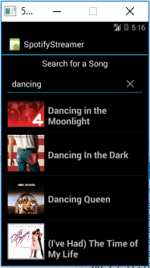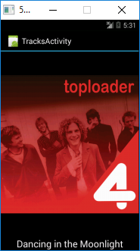

**Layout of the app**

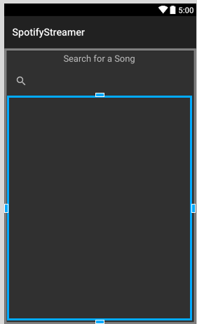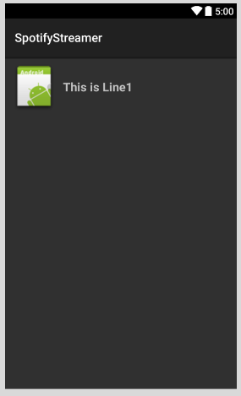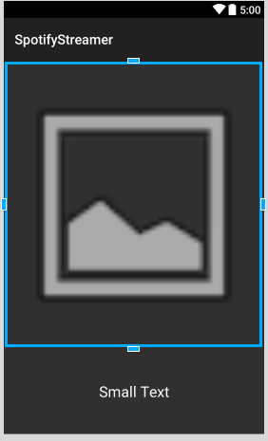

MainActivity.axml CustomRow.axml Track.axml

**Permissions Required**

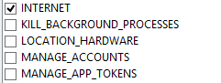 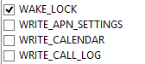

**Read through the documentation of Spotify Web API**

https://developer.spotify.com/web-api/search-item/

**Searching for a track**

You can use the following URL to search for a track

https://api.spotify.com/v1/search?q=abba&type=track&market=NZ

Copy paste the URL in the browser to get the JSON format

Go to json2csharp.com

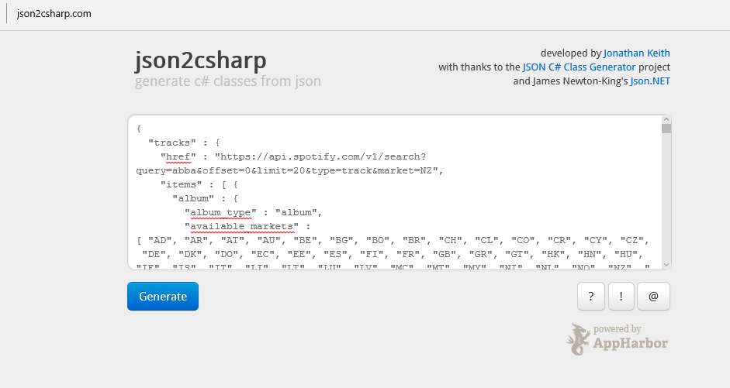

**Click generate**

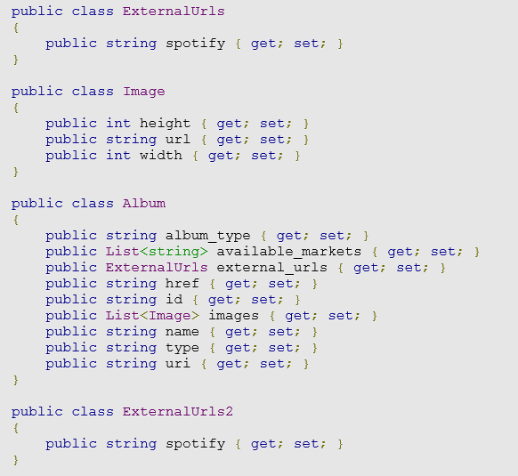

Create Response.cs class and copy the generated code

Copy RESThandler.cs from your previous JSON project

Add the components or Nuget packages (Restsharp and Newtonsoft.JSON)

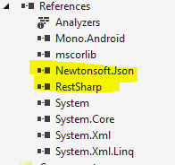

**Copy the DataAdapter.cs**

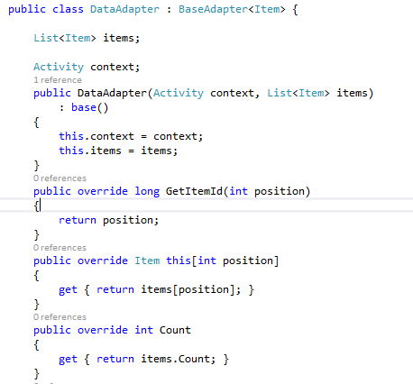

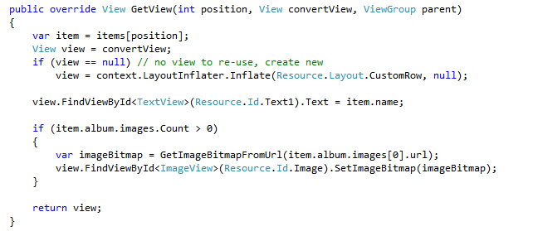

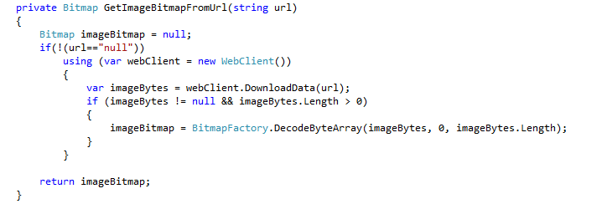

**MainActivity.cs**

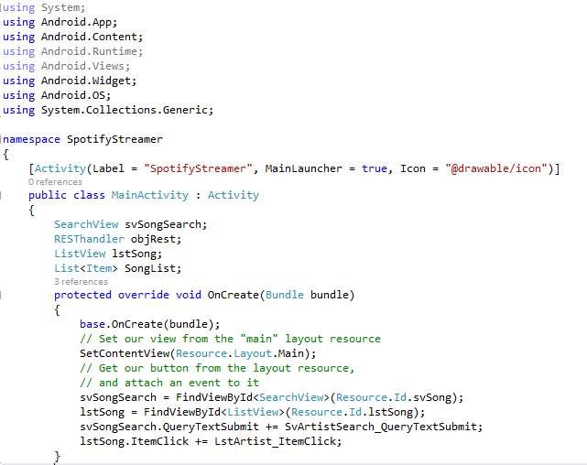

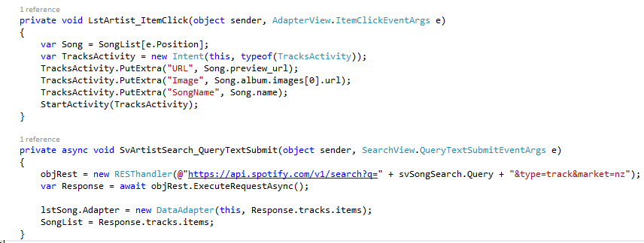

**TracksActivity.cs**

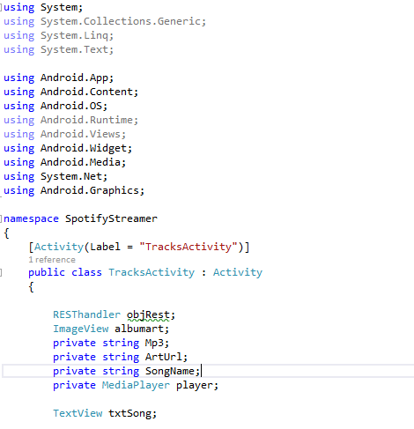

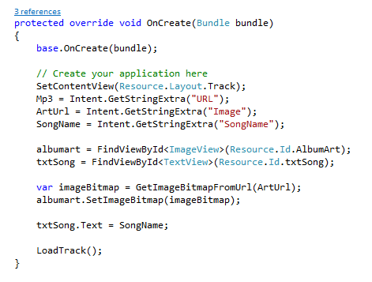

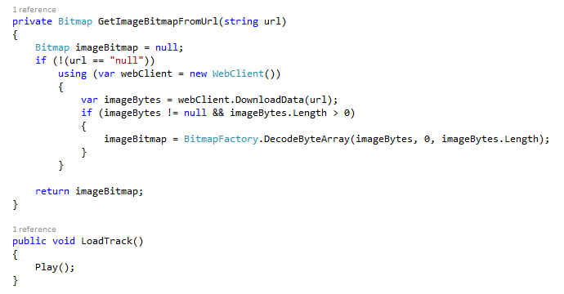

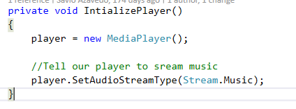

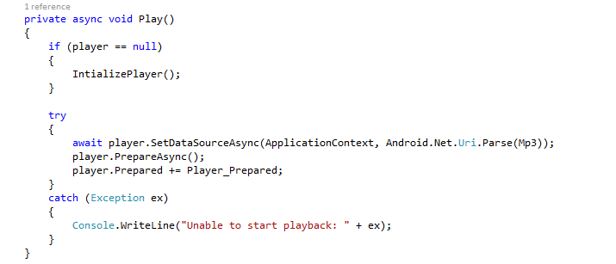

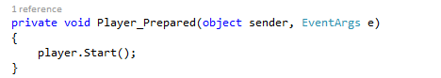

**Exercise**

Implement the pause and play buttons for the player

Try to have a prev and next button as well